

Database Project Report

Report



Name ID’s

1-Omar Mohamed Faramawy 5364

2-Omnia Yassen Abdoh 5807

3- Nehal Khaled Ibrahim 7118

4-Mariam Said Khalil 6902

**1-ER Diagram:**

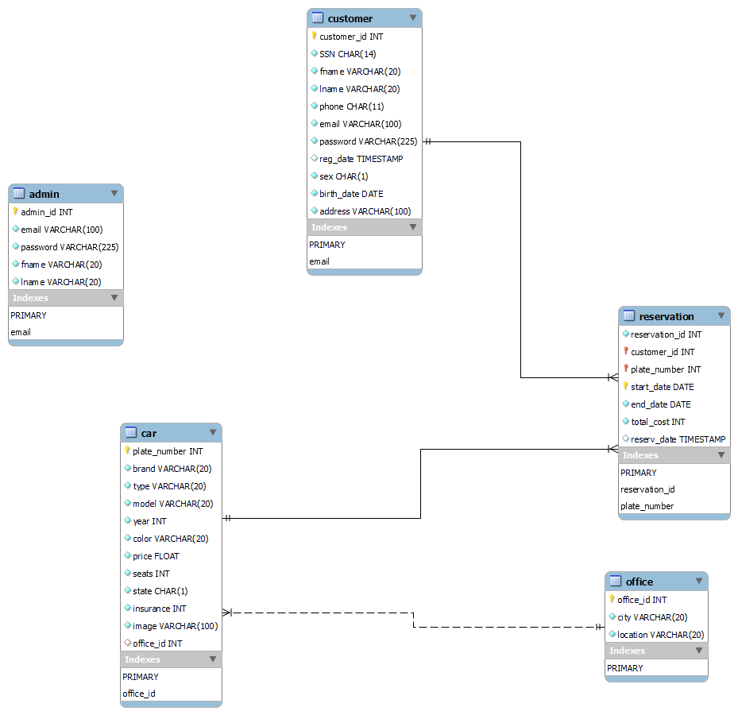

**2-Description of Screens:**

2-1: Signing Up

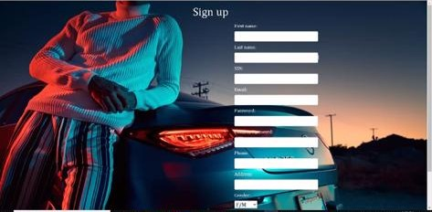

Description:

1-User Enters his credentials to make an account Website

2-2: Logging In

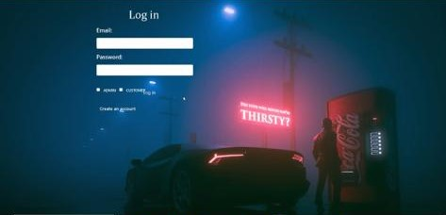

Description:

User uses his saved credentials to log in to system

2-3: Admin Page



Description:

Admin page where user can Reserve , modify and search for a car

2-4 Adding a Car

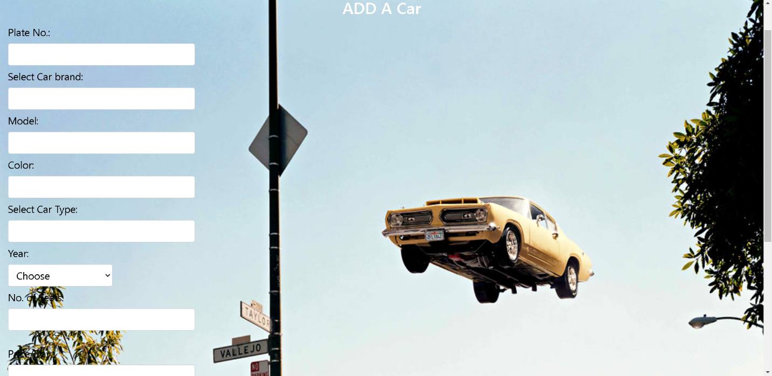

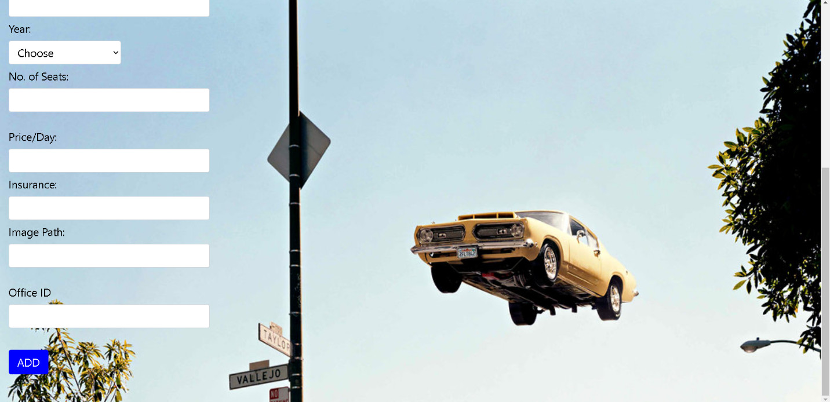

Description:

Responsible for adding a car by specifying the car specifications like (plate number, car brand , car model ..etc)

2-5: Modifying The Cars Specifications:

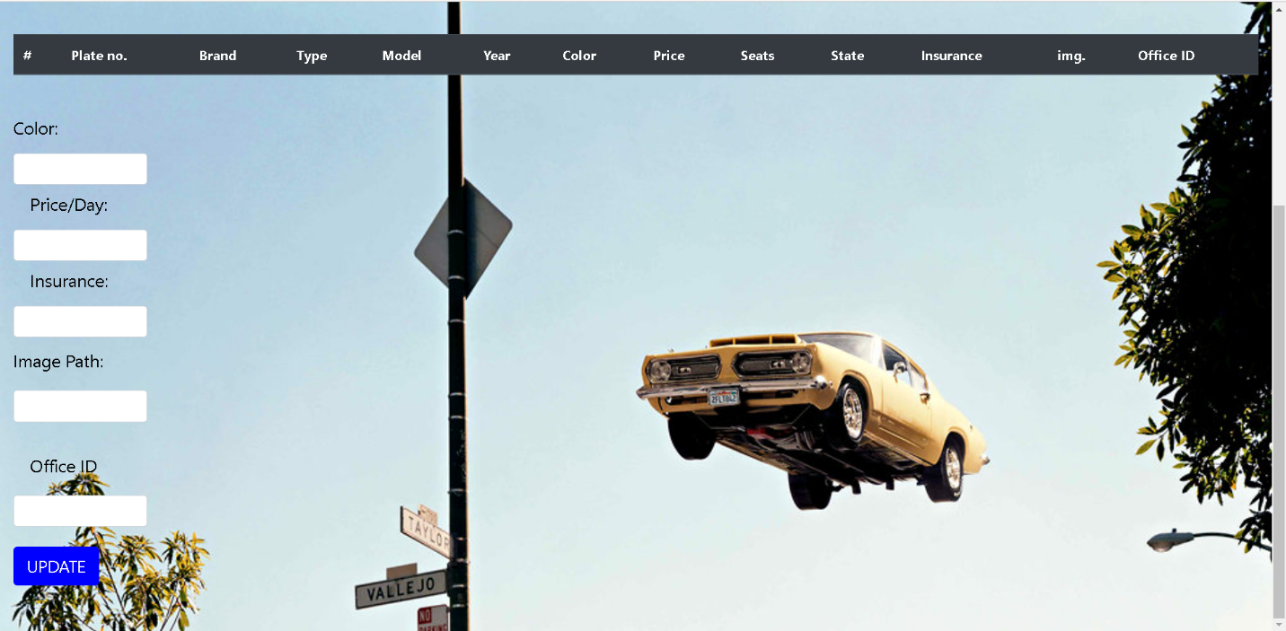

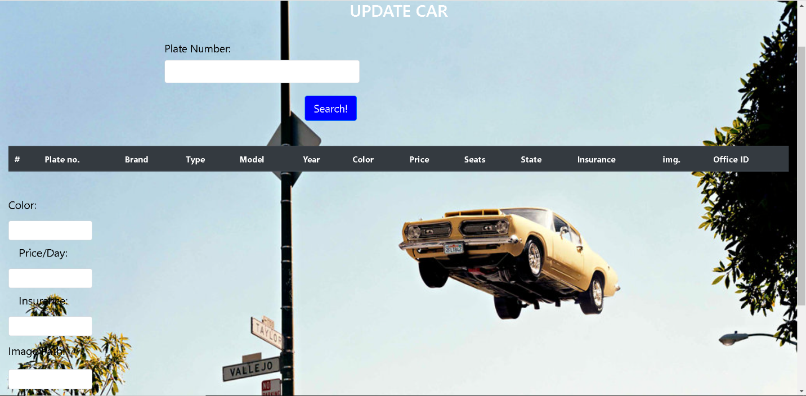

Description:

1-User Enters The plate Number of the car

2- Database is searched by that plate number and return all information of car if it exists

3-User enters the new specifications he want to update

4- New specifications is saved in Database

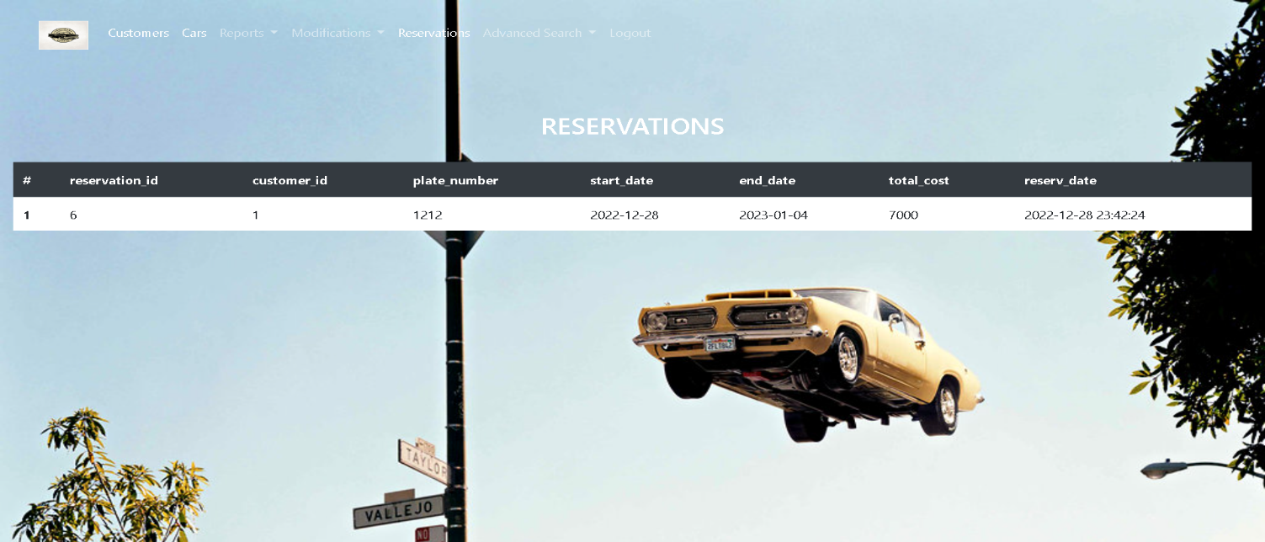2-6: Reservations

Description:

1-Page Responsible for viewing all the reserved cars

2-7: Reservation of customer by Email:

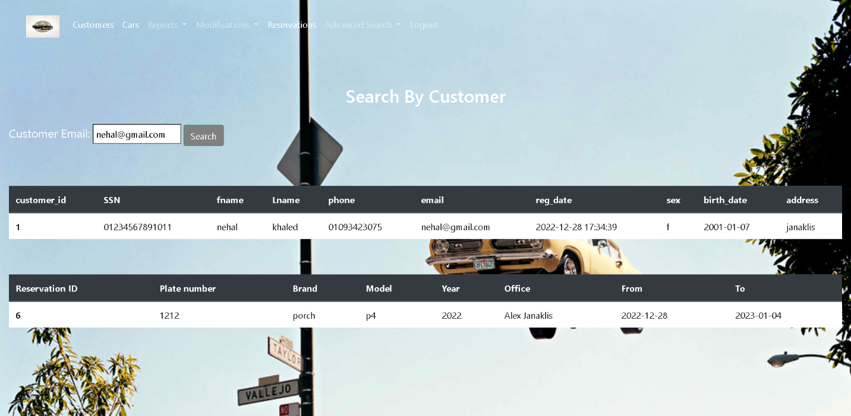

Description:

1. Entering the required Email to Fetch for all reserved car by that person
2. Searching Database by using Email
3. Database returns all Reserved cars by that person if email exists in the Database

2-8 Customers

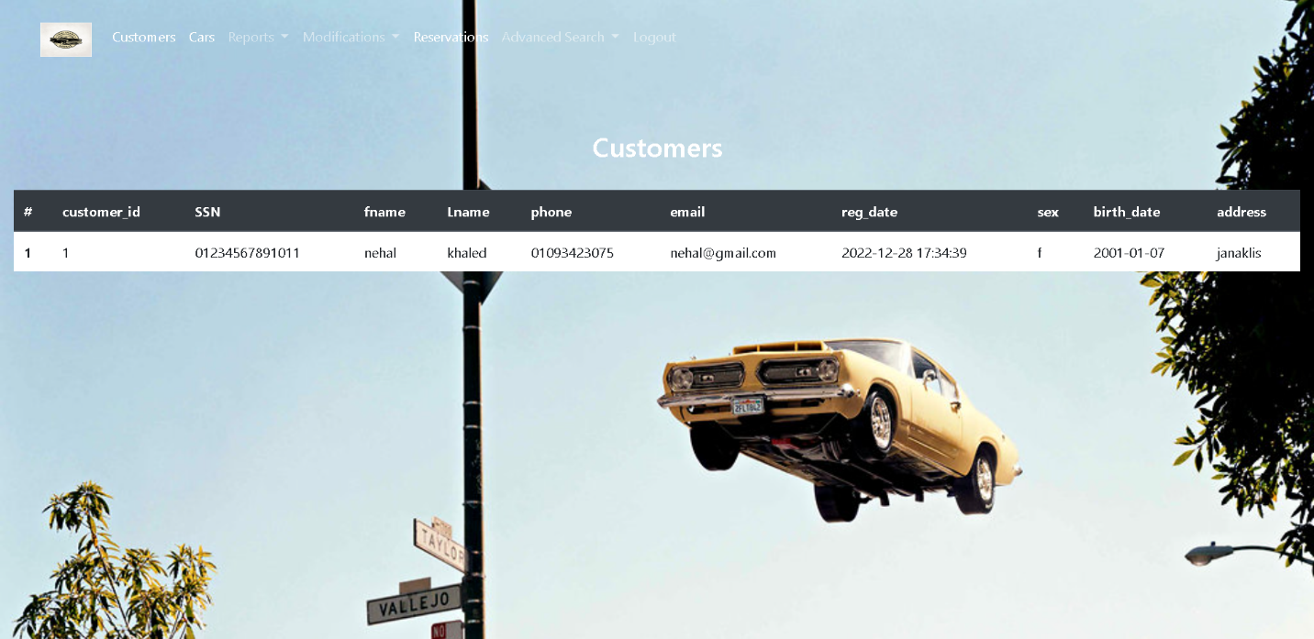

Description:

1-Responsble for Viewing all Registered customer within system (whether they reserved a car or not)

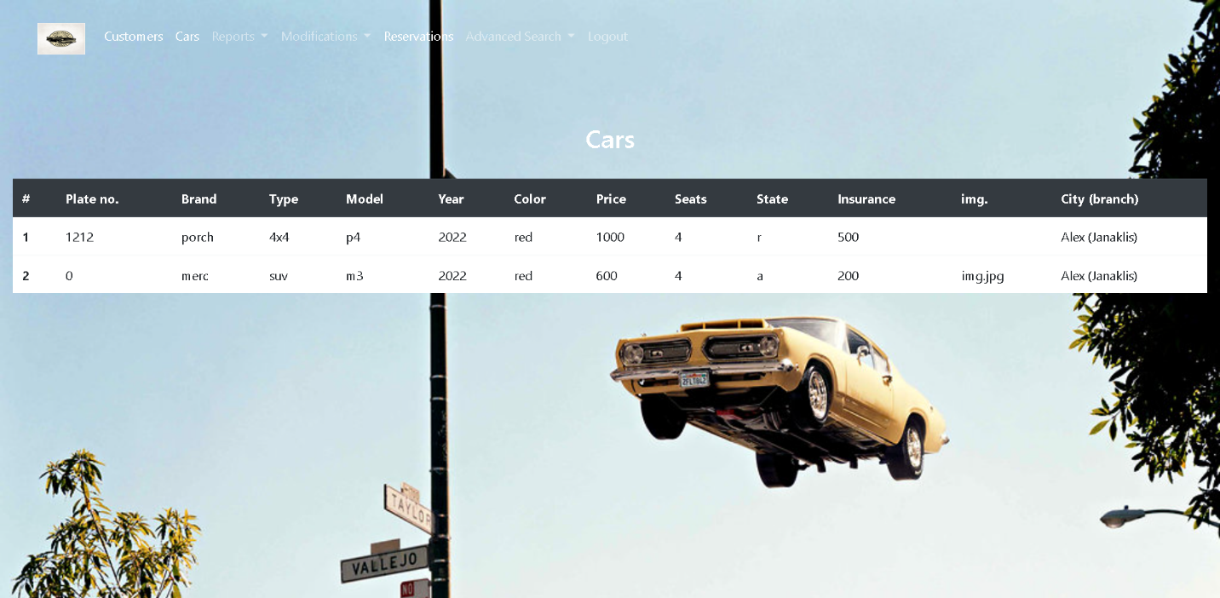2-9 Cars

Description:

1-Responsible for viewing all The cars on the system whether they are reserved or available

2-10: Reserved Cars Given a Specific Date

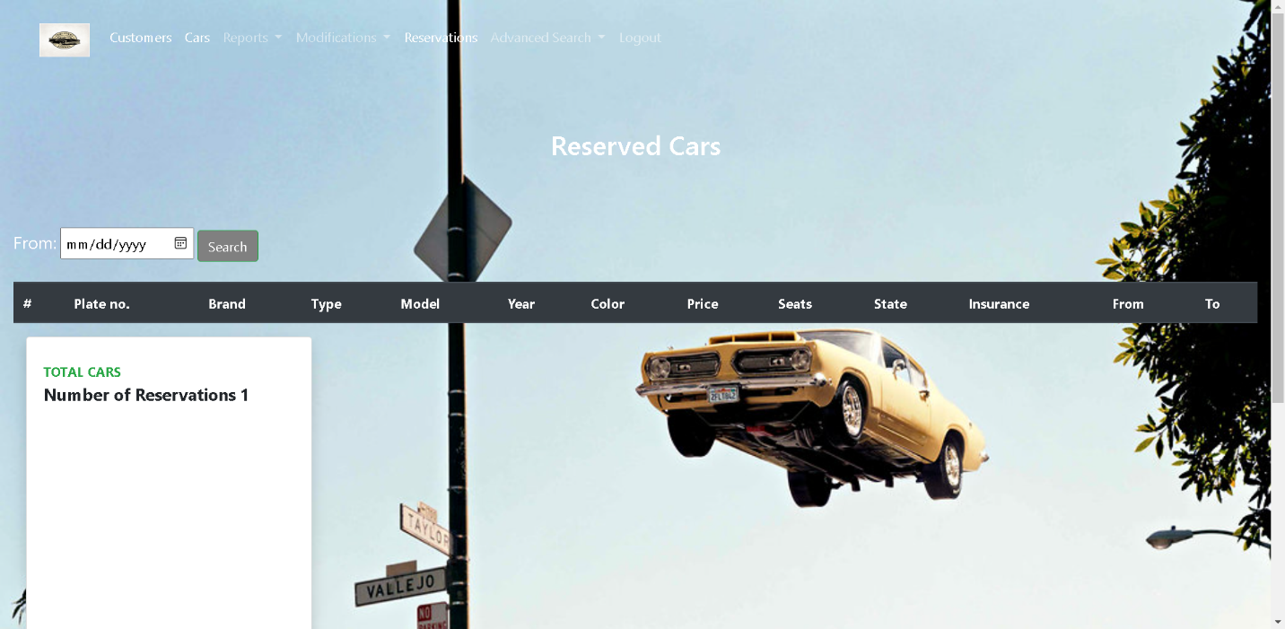

Description:

1-View all the reserved Cars that happen in that date

2-11: Reserved Cars within specific range

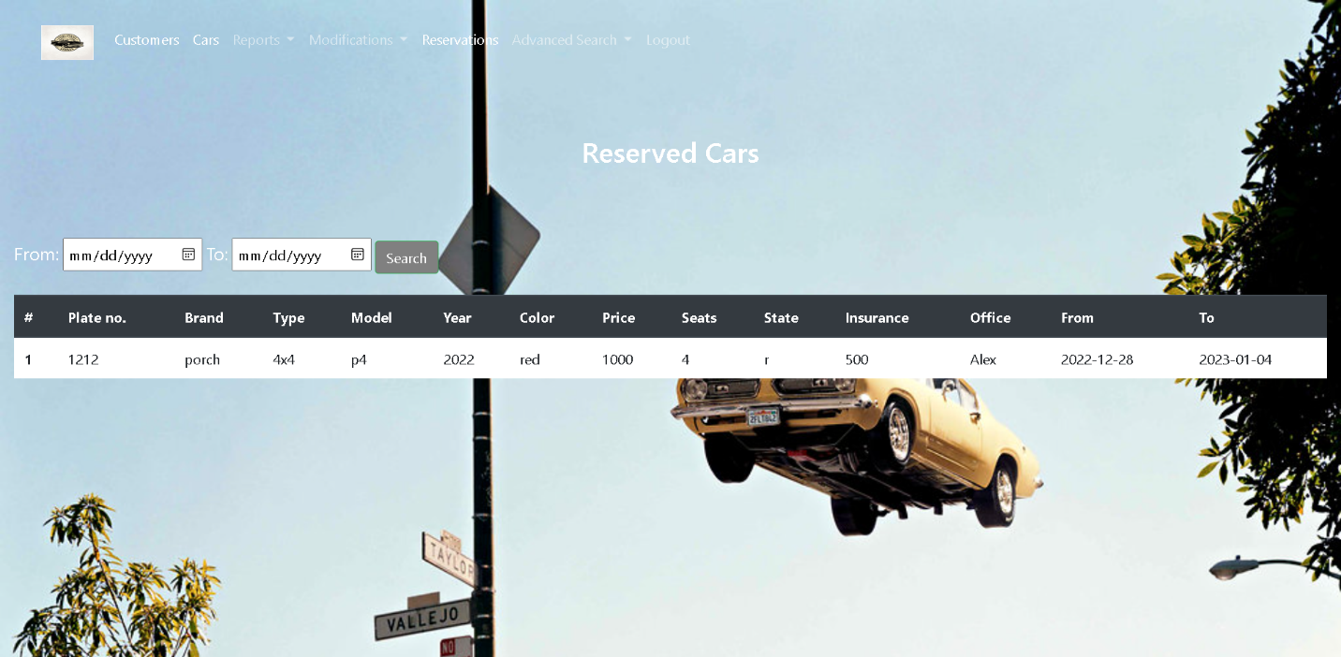

Description:

1-Views all the Reserved Cars within specific range of date

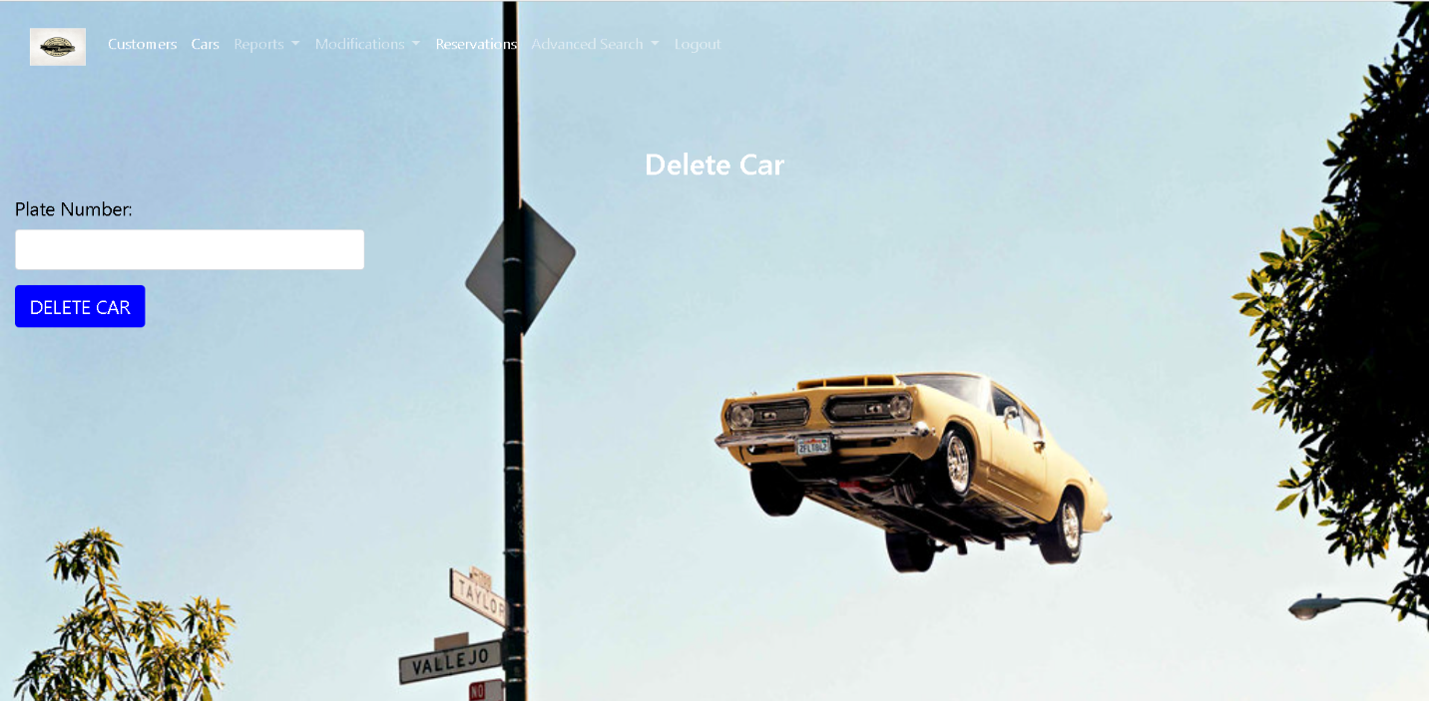2-12: Deleting a car

Description:

1-Deletes a car from database

2-User Enters the plate number of the car required to be deleted

3-Database is searched with that plate number and return the whole record of the car if exists

2-13: Daily Payments

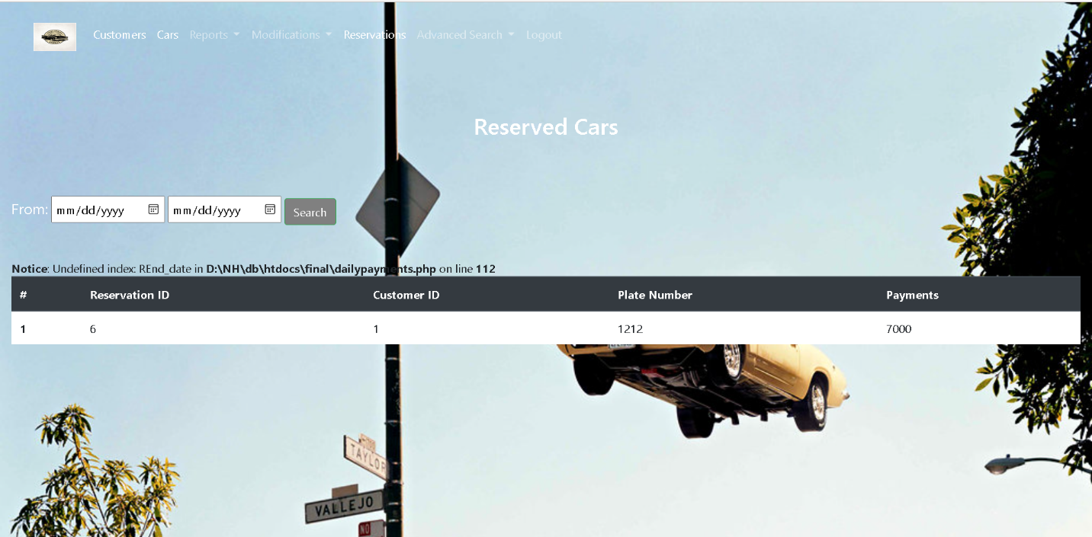

Description:

1-Returns all the cars that have been reserved given a specific date range

2-Return total payment done for each car

2-14: Advanced Search by Customer

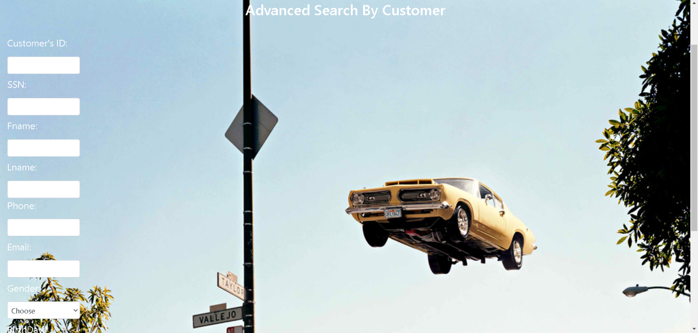

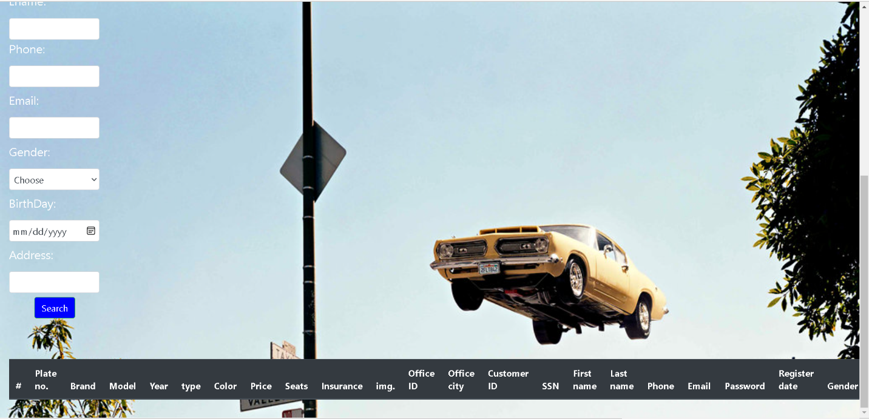

Description:

1-Responsible for viewing all the information of user and the cars that he reserved

2-Enter User credentials that you want to search for

3-Database is Searched with these attributes and return all the information of user and the cars he reserved if user exists

2-15: Advanced Search by Reservations

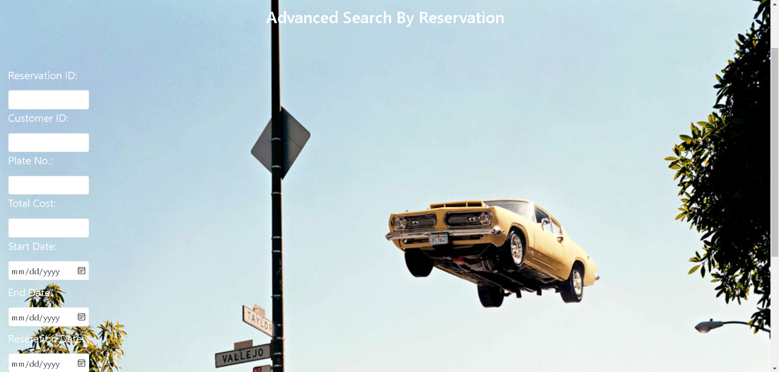

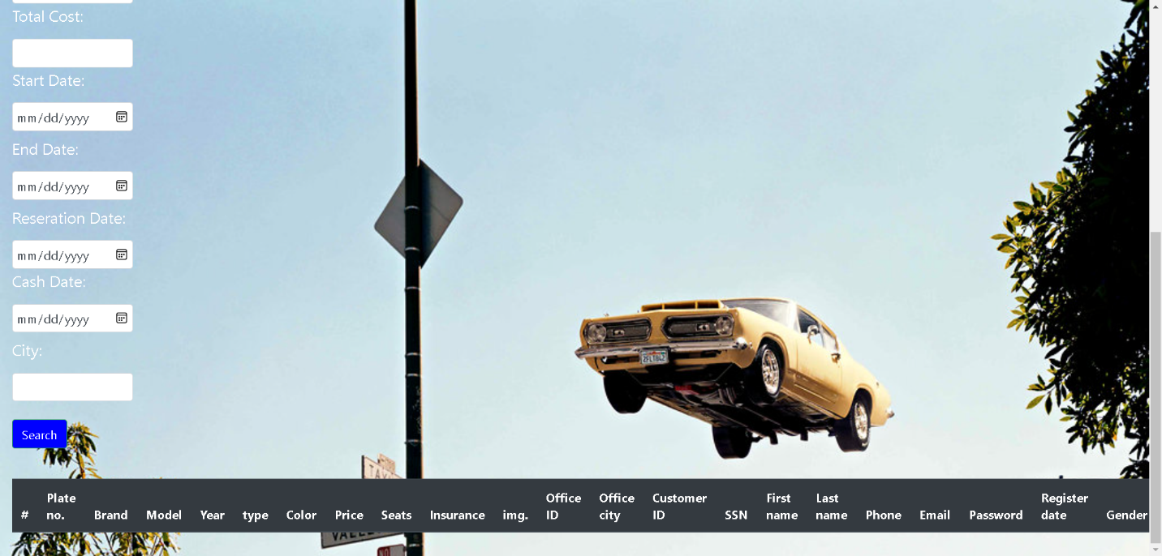

Description:

1-Responsible for viewing all the information of user and the cars that he reserved

2-Enter car credentials that you want to search for

3-Database is Searched with these attributes and return all the information of user and the cars he reserved if user exists

2-16: Advanced Search by car

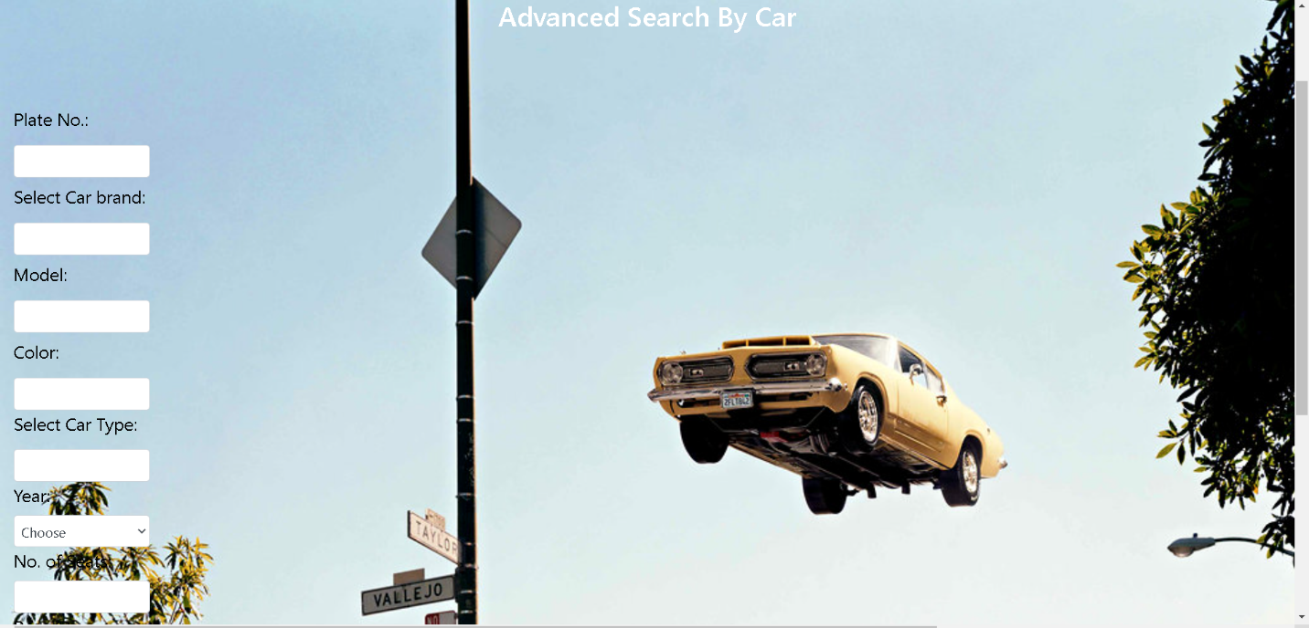

Description:

1-Views all the cars in the system given the car specifications

2- User Enters Specifications of car that he wants to search for

3-Database is searched by using search attributes and the car is returned (whether it’s reserved or not)

2-17: Reserved Cars and Customers

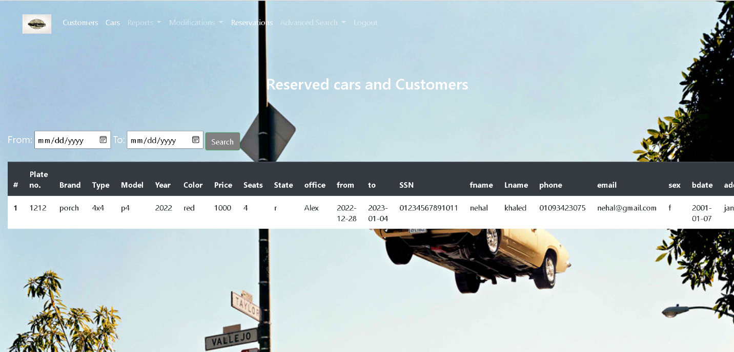

Description:

1. User enter the required date range
2. Returns all information about the car reserved and the person who reserved it given specific date range